Tool Study
Cyber Security Placement — Adversary Test Automation

Contents
01. Lab as code using Vagrant
02. Security Telemetry and Monitoring
03. Atomic Red Team

Tool Study 01: Lab as code using Vagrant
12 October 2026

1. Overview
Vagrant uses a configuration file to define virtual machines and their settings. It works with a provider such as VirtualBox to create and manage the environment.

2. How It Works

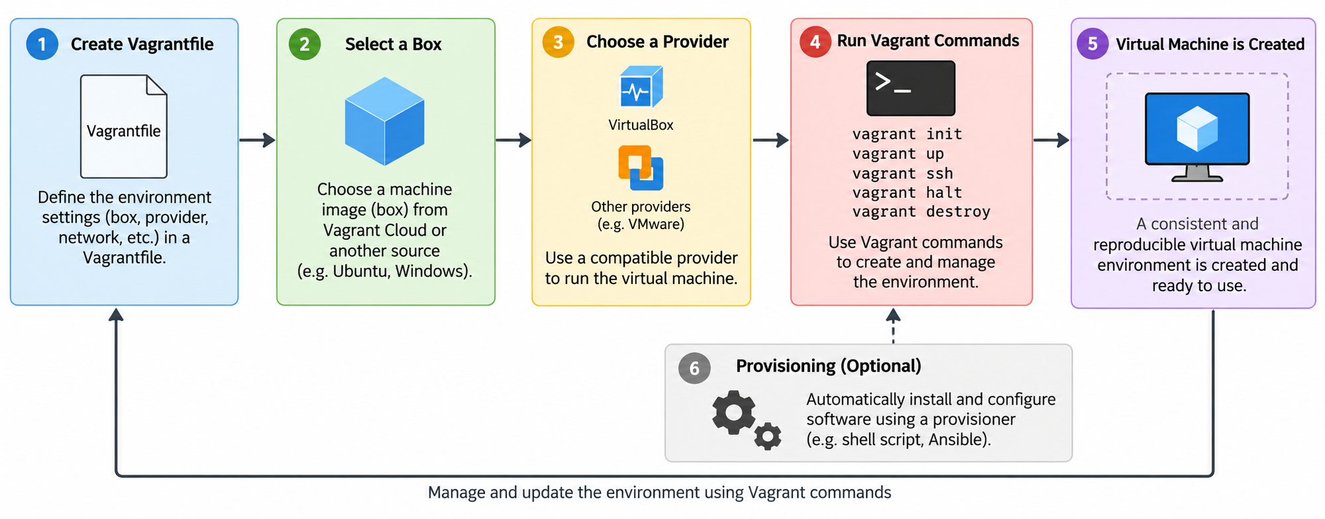

3. Key Features & Requirements
Key features
- Environment setup can be defined and repeated through configuration.
- Configuration files can be tracked in Git.
- Provisioning can automate additional setup tasks.
Requirements
Vagrant, a compatible provider, sufficient system resources, and any required software permissions. The exact requirements depend on the selected provider and environment.

4. Practical Investigation
Activity
- Reviewed the Vagrant configuration and provisioning scripts.
- Checked the virtual machines and network settings.
- Tested the lab setup after rebuilding the environment

Findings
- Vagrant makes the lab easier to recreate.
- Provisioning scripts reduce manual setup.
- Network settings must be checked to avoid IP conflicts and maintain isolation.

5. Project Application
Vagrant helps create a repeatable lab for cybersecurity testing and makes it easier to rebuild the environment when needed.

6. Learning Reflection & Next Steps
Learning reflection: I learned how Vagrant uses configuration files and provisioning to automate lab setup.
Next steps: Use the lab to run safe security tests and check the collected events.

7. Sources
- Vagrant (https://developer.hashicorp.com/vagrant/docs)

Tool Study 02: Security Telemetry & Monitoring
12 October 2026

1. Overview
Sysmon records Windows system activity, while auditd records configured Linux audit events. Wazuh collects and analyses events from both systems and displays relevant alerts in its dashboard.

2. How It Works
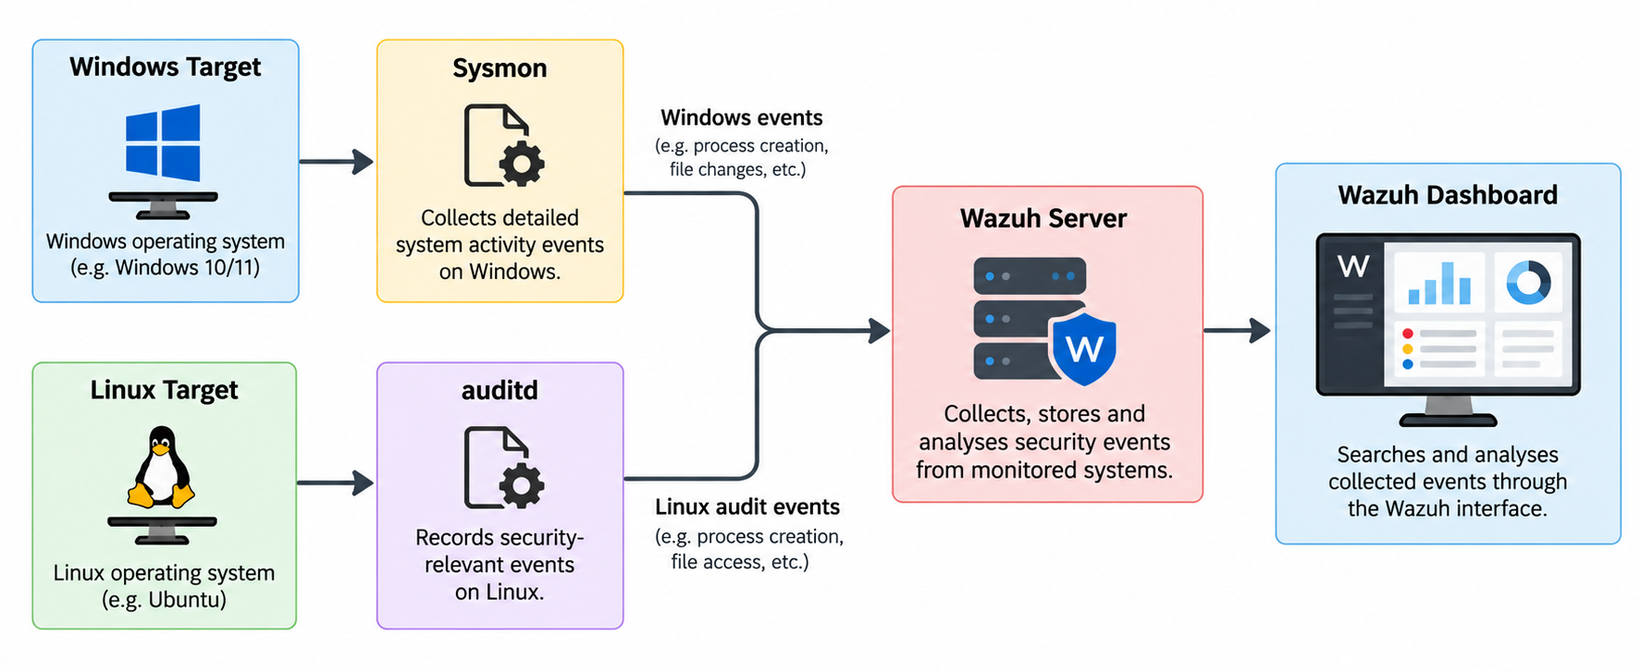

3. Key Features & Requirements
- Sysmon: Collects detailed Windows system events.
- auditd: Records configured Linux audit events.
- Wazuh: Provides centralised security monitoring.

The setup requires compatible systems, appropriate configurations, and connectivity between the components.

4. Practical Investigation
Activity:
- Deployed Wazuh using Docker.
- Configured auditd and the Wazuh agent on Ubuntu.
- Configured Sysmon and the Wazuh agent on Windows.
- Generated test activity and checked the events in Wazuh.
Findings:
- Ubuntu process events were collected and detected by a custom Wazuh rule.
- Windows Sysmon process events were received by Wazuh.
- Extra logging or rules may be needed to detect file access, deletion and startup changes.

5. Project Application
These tools help me check whether activity from the selected security tests is recorded and detected by Wazuh.

6. Learning Reflection & Next Steps
Learning reflection: I gained an insight on how to collect events from Windows and Ubuntu using Sysmon, auditd and Wazuh.
Next steps: Test selected ATT&CK techniques and compare the results with the events recorded by Wazuh.

7. Sources
- Sysmon (https://learn.microsoft.com/en-us/sysinternals/downloads/sysmon)
- auditd (https://github.com/linux-audit/audit-userspace)
- Wazuh (https://documentation.wazuh.com/current/)

Tool Study 03: Atomic Red Team
21 October 2026

1. Overview
What is it?
Atomic Red Team is a security testing framework that provides tests mapped to MITRE ATT&CK techniques. It uses YAML files to define test procedures, prerequisites, execution commands and cleanup steps.

2. How It Works
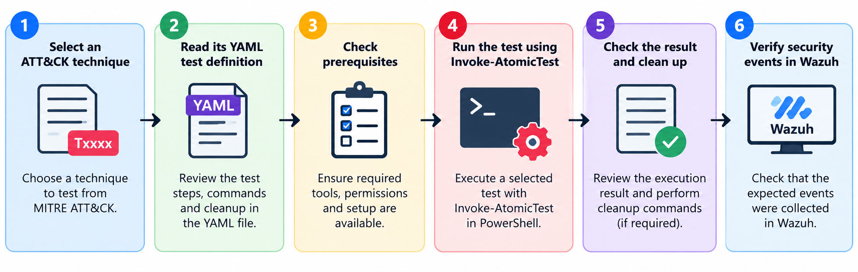

3. Key Features & Requirements
- Provides tests mapped to MITRE ATT&CK techniques.
- Stores test definitions in YAML files.
- Supports test execution, prerequisite checks and cleanup.
- Help validate security monitoring and detection.
PowerShell, the Invoke-AtomicRedTeam module, the Atomic Red Team YAML definitions, and an authorised test environment. Some tests require additional tools or privileges.

4. Practical Investigation
Activity:
- Retrieved and parsed YAML definitions for 12 selected ATT&CK techniques.
- Inspected available tests and executed selected tests using Invoke-AtomicTest.
- Recorded execution results and cleanup outcomes.
Findings:
- YAML definitions provide structured information about available tests.
- Test execution and cleanup results need to be recorded for repeatability.
- Several tests require extra prerequisites or may modify system settings.

5. Project Application
Atomic Red Team supports repeatable adversary testing in the cybersecurity lab. Test results can be compared with Ubuntu audit and Windows Sysmon events collected by Wazuh to evaluate security monitoring.

6. Learning Reflection & Next Steps
Learning reflection: I learned how Atomic Red Team organises ATT&CK tests in YAML and how selected tests can be executed and documented using Invoke-AtomicTest.
Next steps: Confirm the execution requirements.

7. Sources
- Atomic Red Team: https://github.com/redcanaryco/atomic-red-team
- Invoke-AtomicRedTeam: https://github.com/redcanaryco/invoke-atomicredteam

Tool Study 04: CALDERA
23 October 2026

1. Overview
What is it?
CALDERA is an automated adversary emulation platform developed by MITRE. It uses MITRE ATT&CK techniques to simulate adversary behaviours in an authorised environment and help evaluate security monitoring and detection.

2. How It Works
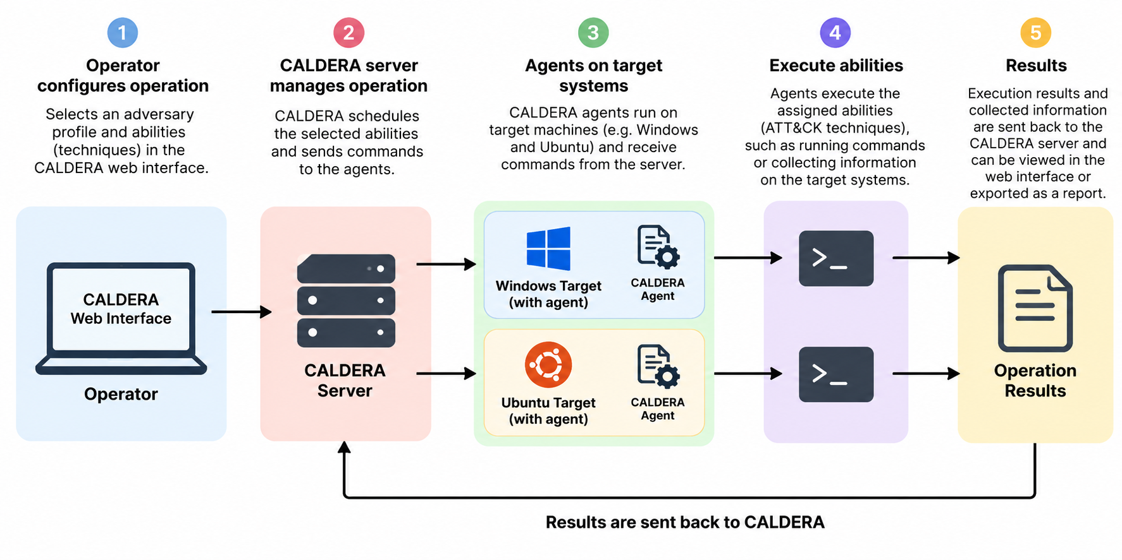

3. Key Features & Requirements
- Supports adversary emulation based on MITRE ATT&CK.
- Uses adversary profiles and abilities to define operation behaviour.
- Deploys agents to communicate with target systems and execute selected abilities.
- Supports automated operations and result reporting.
Requires CALDERA server software, a compatible environment, configured agents and authorised target systems.

4. Practical Investigation
Activity:
- Install and configure CALDERA on a separate Ubuntu Server virtual machine.
- Configure network connectivity between the CALDERA server and the Windows and Ubuntu targets.
- Deploy agents to both target systems and verify their connectivity.
- Configure and execute a suitable adversary operation.
- Export the operation report in JSON format and record the results.
Findings:
- a

5. Project Application
A

6. Learning Reflection & Next Steps
Learning reflection: a
Next steps: a

7. Sources
- MITRE CALDERA: https://github.com/mitre/caldera
- CALDERA Documentation: https://caldera.readthedocs.io/

